1.Creating a class for a student with a constructor and destructor
#include <iostream>
#include <string>
using namespace std;
class Student {
private:
string name;
int rollNo;
public:
// Constructor
Student(string n, int r) {
name = n;
rollNo = r;
cout << "Constructor called for " << name << endl;
}
// Destructor
~Student() {
cout << "Destructor called for " << name << endl;
}
// Display details
void display() {
cout << "Name: " << name << endl;
cout << "Roll No: " << rollNo << endl;
}
};
int main() {
Student s("Ramya", 1);
s.display();
return 0;
}

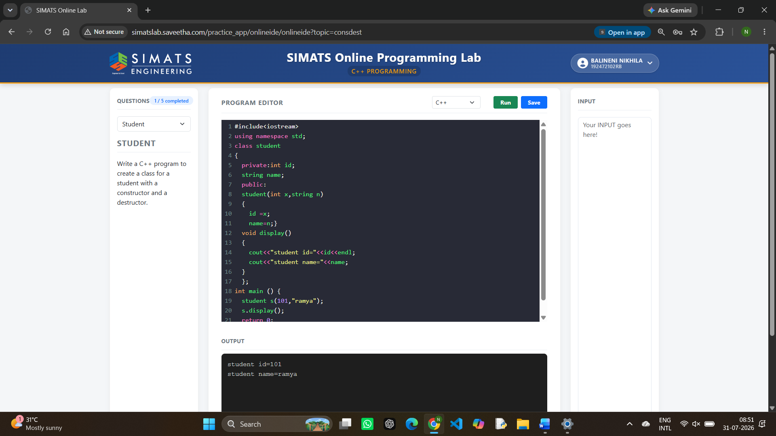

2.Creating a class for a book with a constructor and destructor
#include <iostream>
#include <string>
using namespace std;
class Book {
private:
string title, author;
int pages;
public:
Book(string t, string a, int p) : title(t), author(a), pages(p) {
cout << "Book constructor called: " << title << endl;
}
~Book() {
cout << "Book destructor called for: " << title << endl;
}
void displayDetails() {
cout << "Title : " << title << endl;
cout << "Author : " << author << endl;
cout << "Pages : " << pages << endl;
}
};
int main() {
Book b1("The Great Gatsby", "F. Scott Fitzgerald", 218);
b1.displayDetails();
return 0;
}
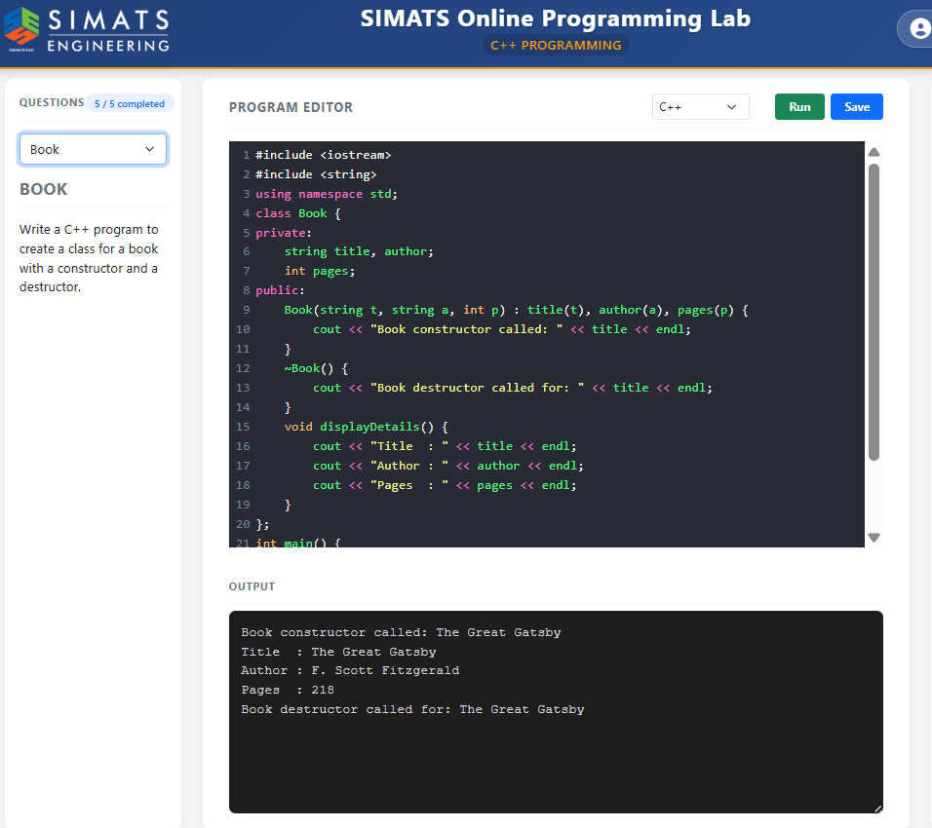

3.Creating a class for a rectangle with a constructor and destructor
#include <iostream>
using namespace std;
class Rectangle {
double length, width;
public:
Rectangle(double l, double w) : length(l), width(w) {} // Constructor
~Rectangle() {} // Destructor
double area() {
return length * width;
}
};
int main() {
Rectangle r(5.0, 3.0);
cout << r.area();
return 0;
}

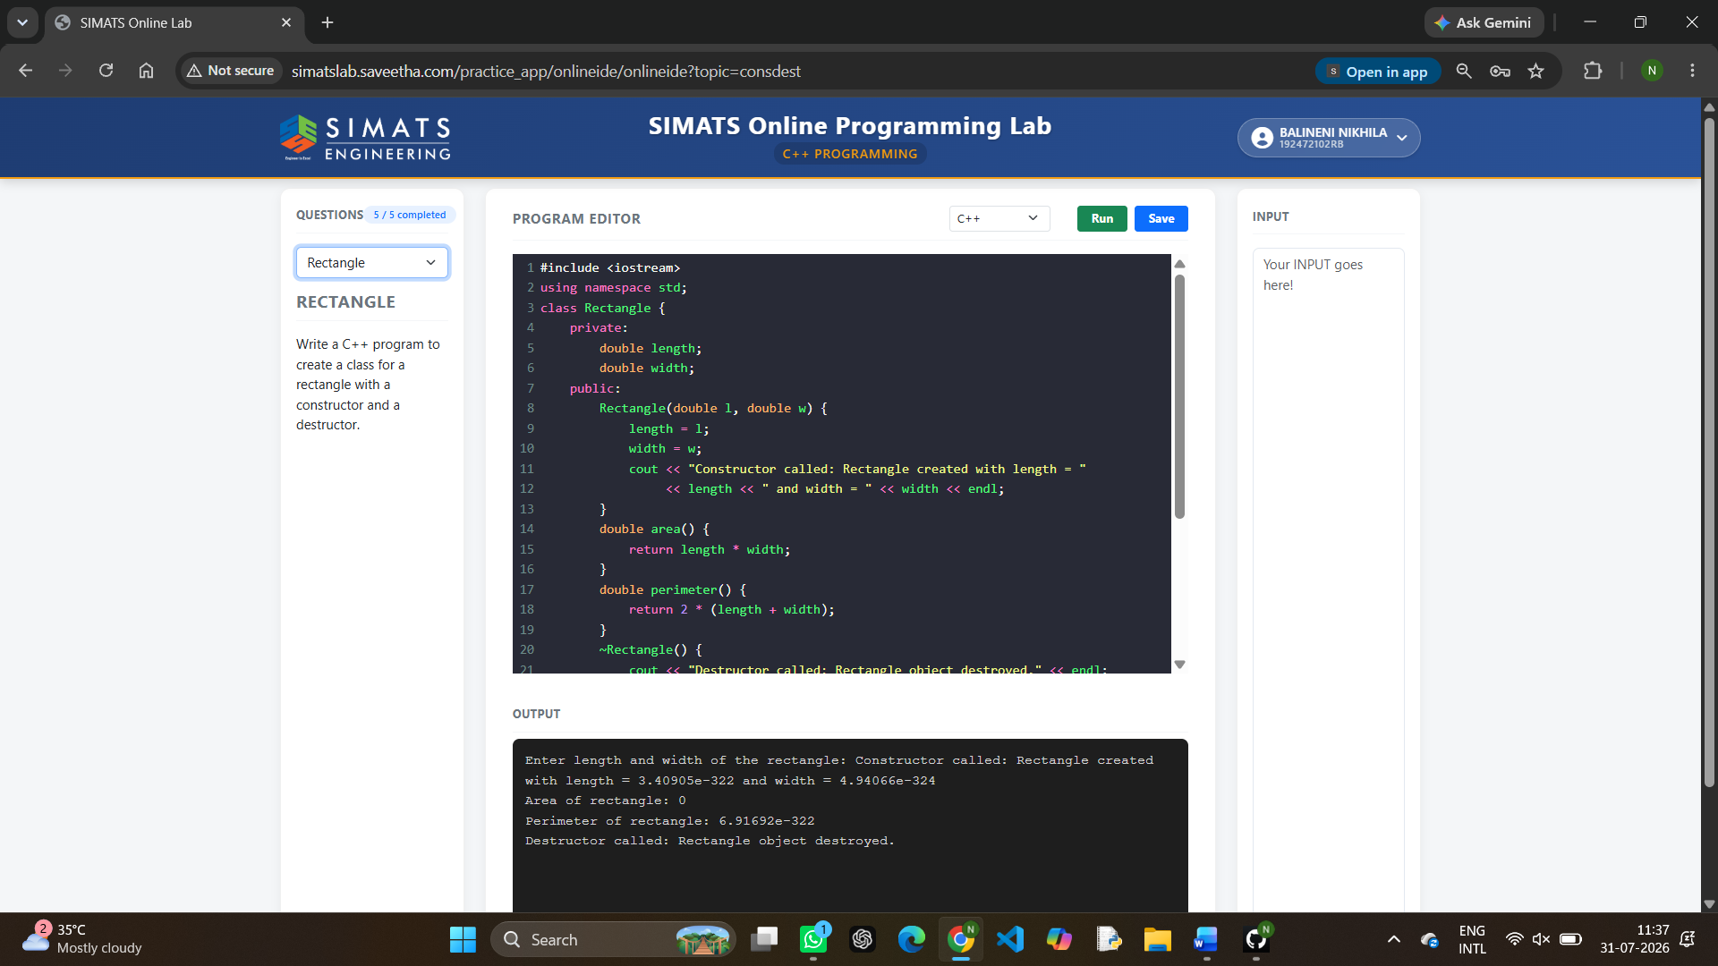

4.Creating a class for a car with a constructor and destructor
#include <iostream>
#include <string>
using namespace std;
class Car {
string model;
public:
Car(string m) : model(m) {} // Constructor
~Car() {} // Destructor
void display() {
cout << model;
}
};
int main() {
Car c("Toyota");
c.display();
return 0;
}

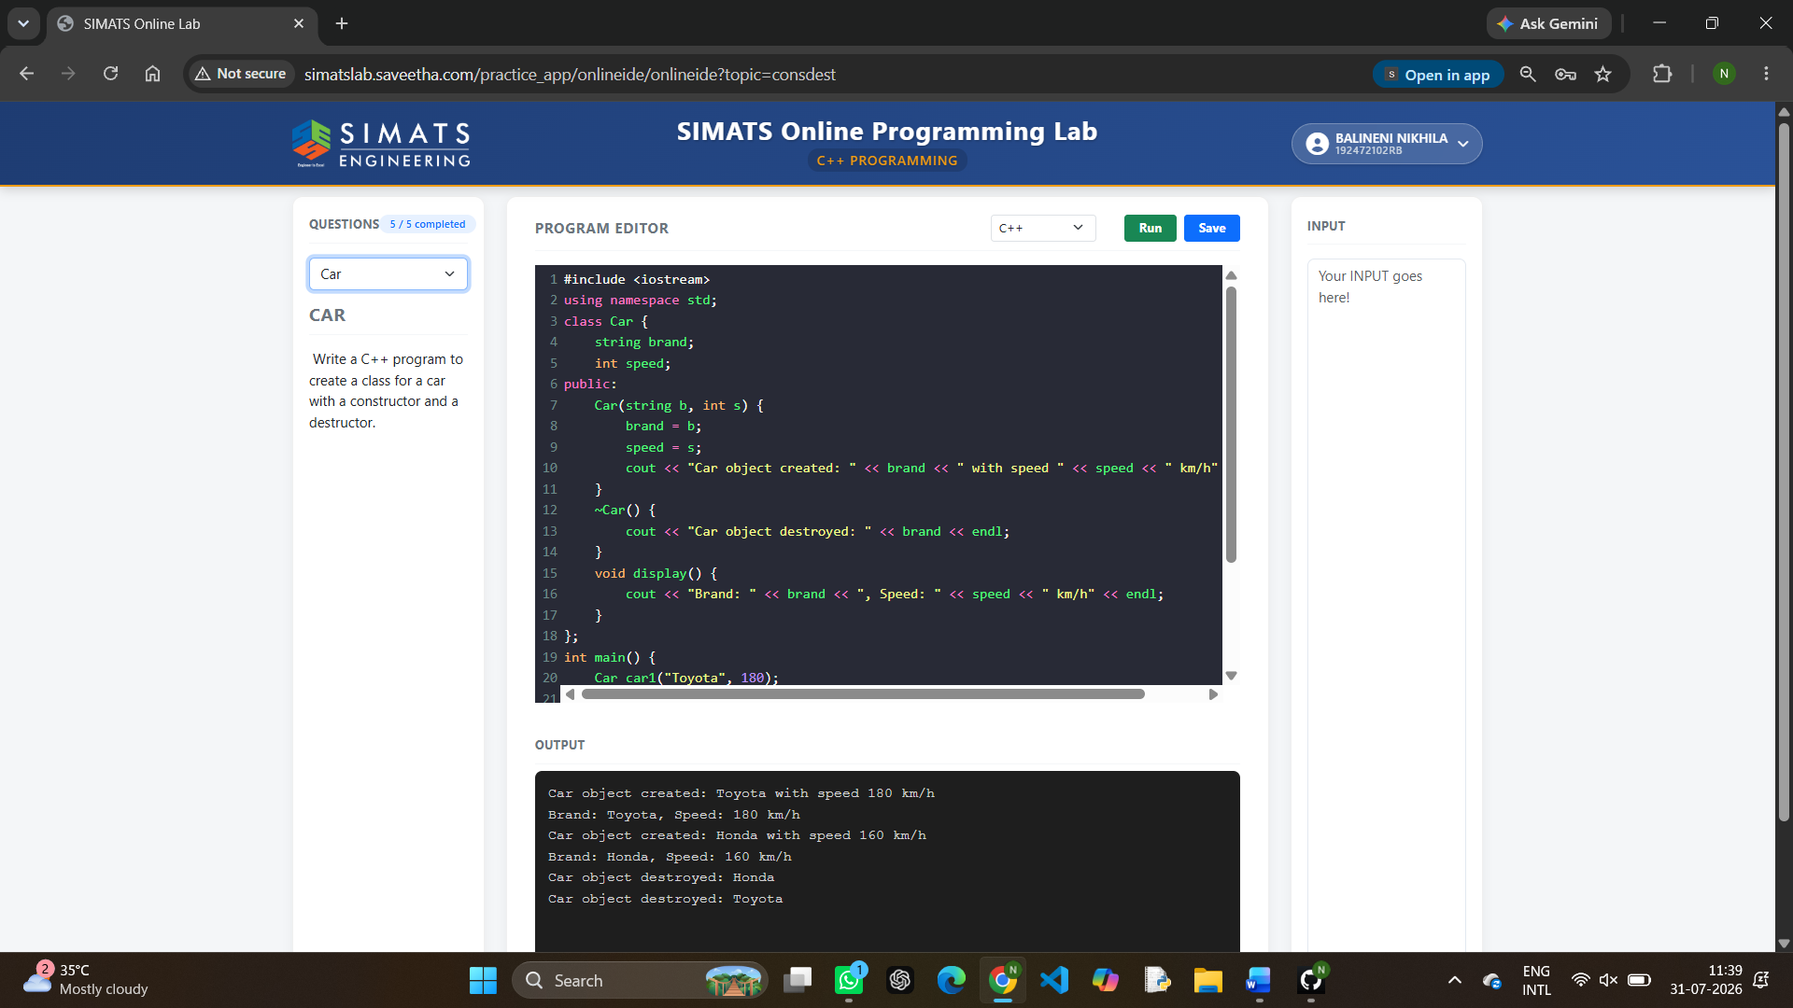

5.Creating a class for a bank with a constructor and destructor
#include <iostream>
#include <string>
using namespace std;
class BankAccount {
string name;
int accNo;
double balance;
public:
// Constructor
BankAccount(string n, int a, double b) : name(n), accNo(a), balance(b) {}
// Destructor
~BankAccount() {}
// Function to display account details
void display() {
cout << "Account Holder: " << name
<< "\nAccount Number: " << accNo
<< "\nBalance: " << balance << endl;
}
};
int main() {
BankAccount acc("Nikhila", 100005, 5000.0);
acc.display();
return 0;
}

